Tracking information

Locally Tracked record using a dual band arrow J pole, USB T3 mini tracker, Motorola M120 radio, aprs point software

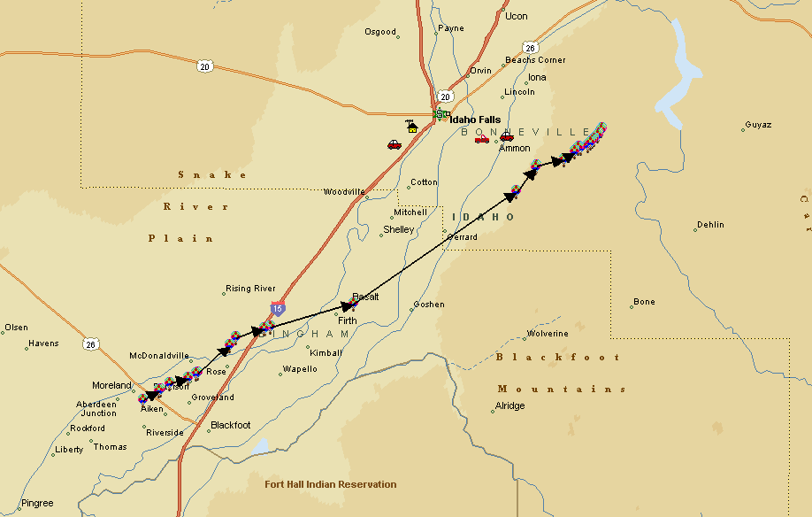

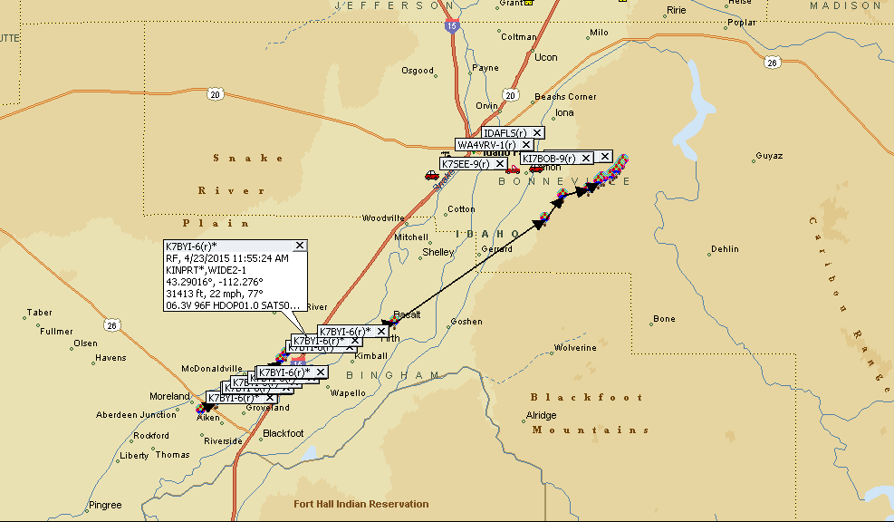

Tracking as received by aprs.fi online

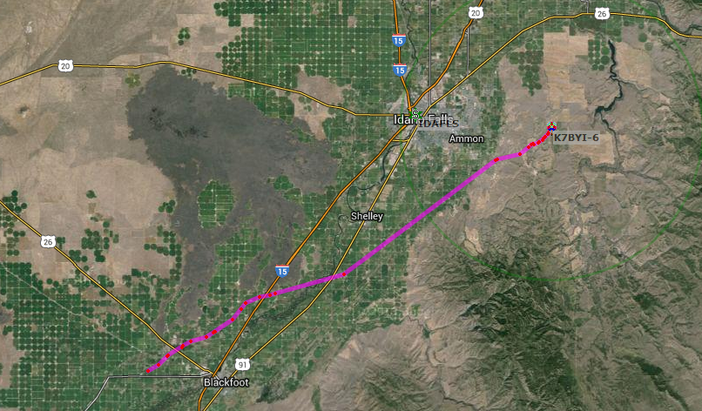

Export of aprs.fi data into google earth (note we lost the gps above around 30k ft (it went to around 80k ft)

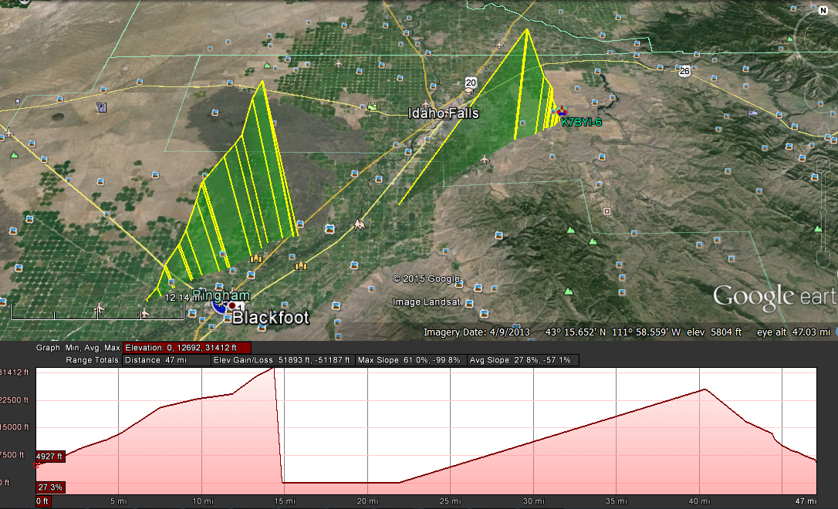

Some basic weather logs

Launch preparations

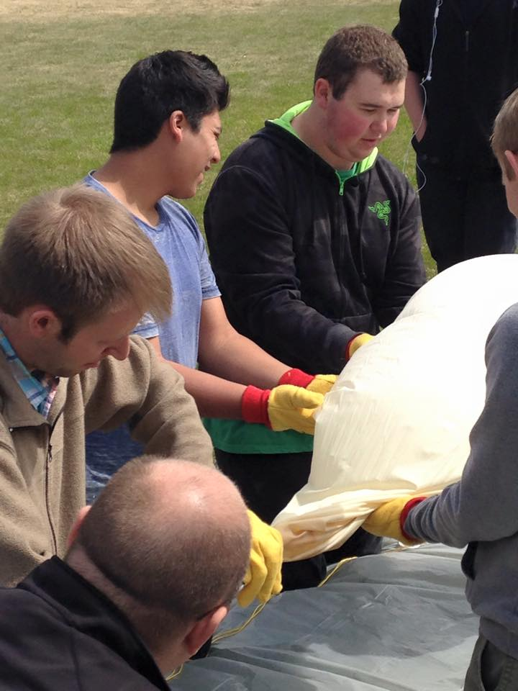

Nearly filled

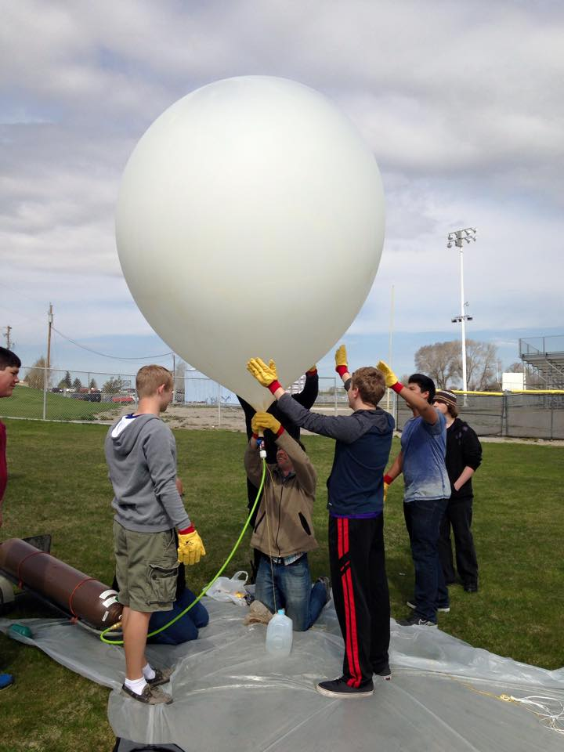

Early Flight

Above Moreland / Thomas area looking down 900W Church house at corner of 900 W & 100 N. (Bingham County Idaho)

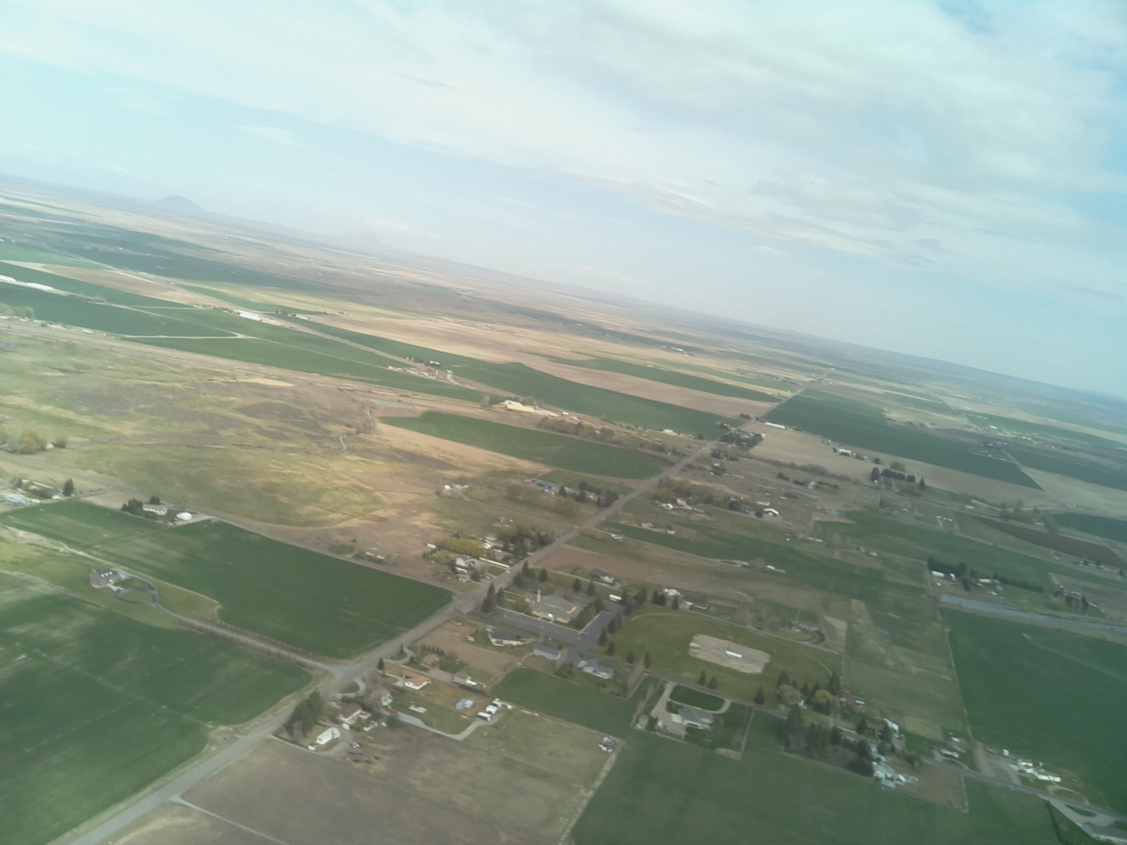

Early Flight (Above Moreland / Thomas area, looking towards Mt. Putnam / Pocatello)

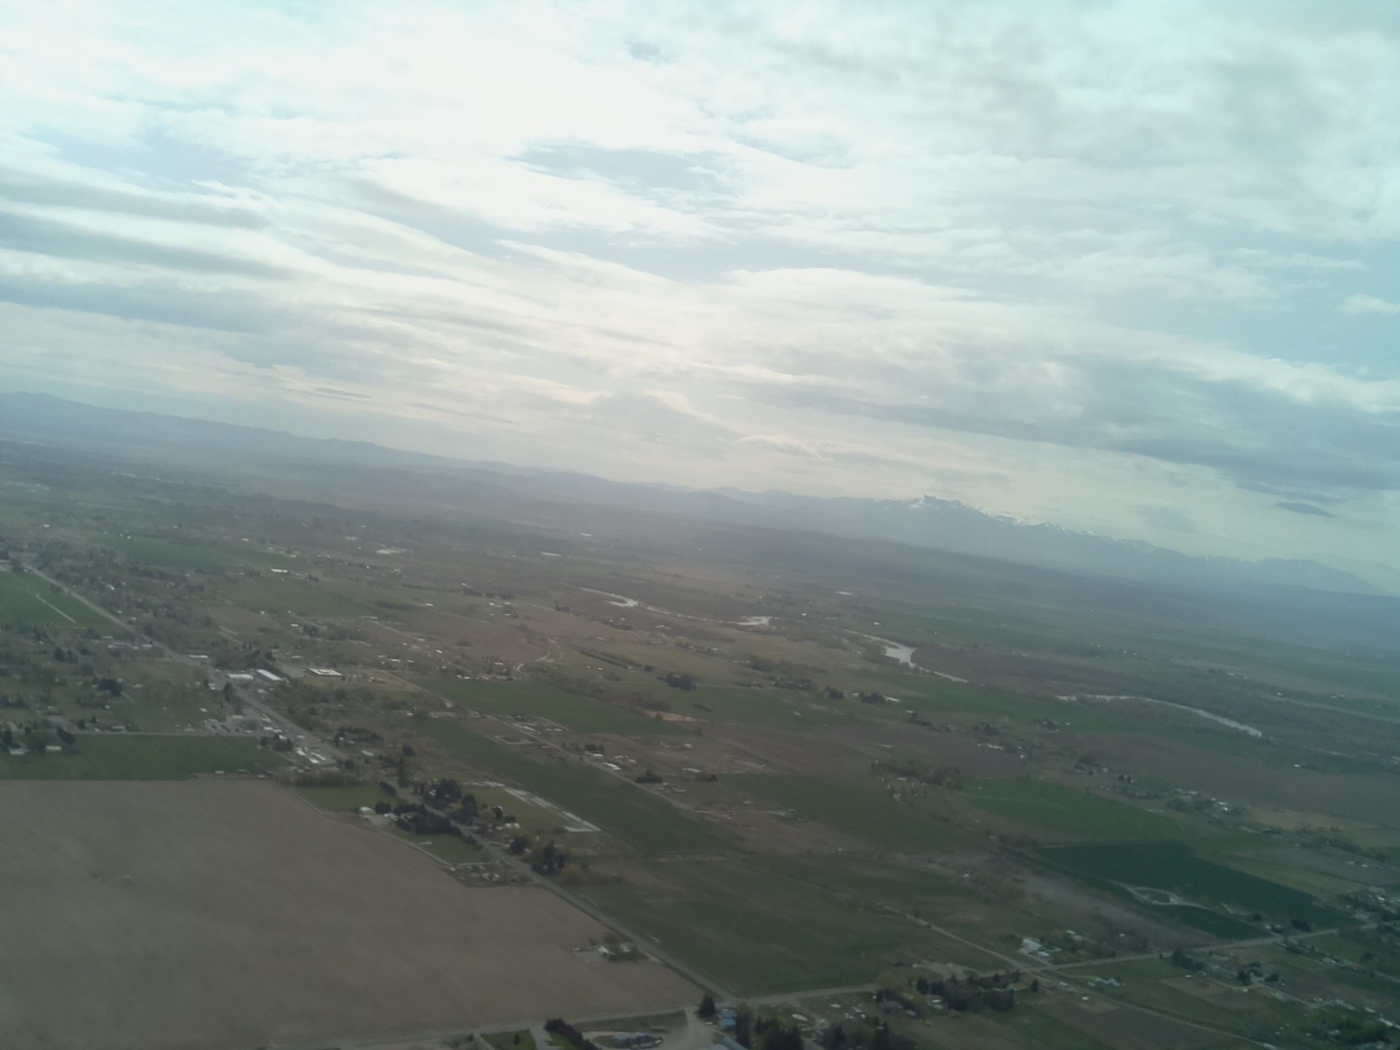

Higher Flight

(Probably near I-15 / Rose area, see Lava Flows)

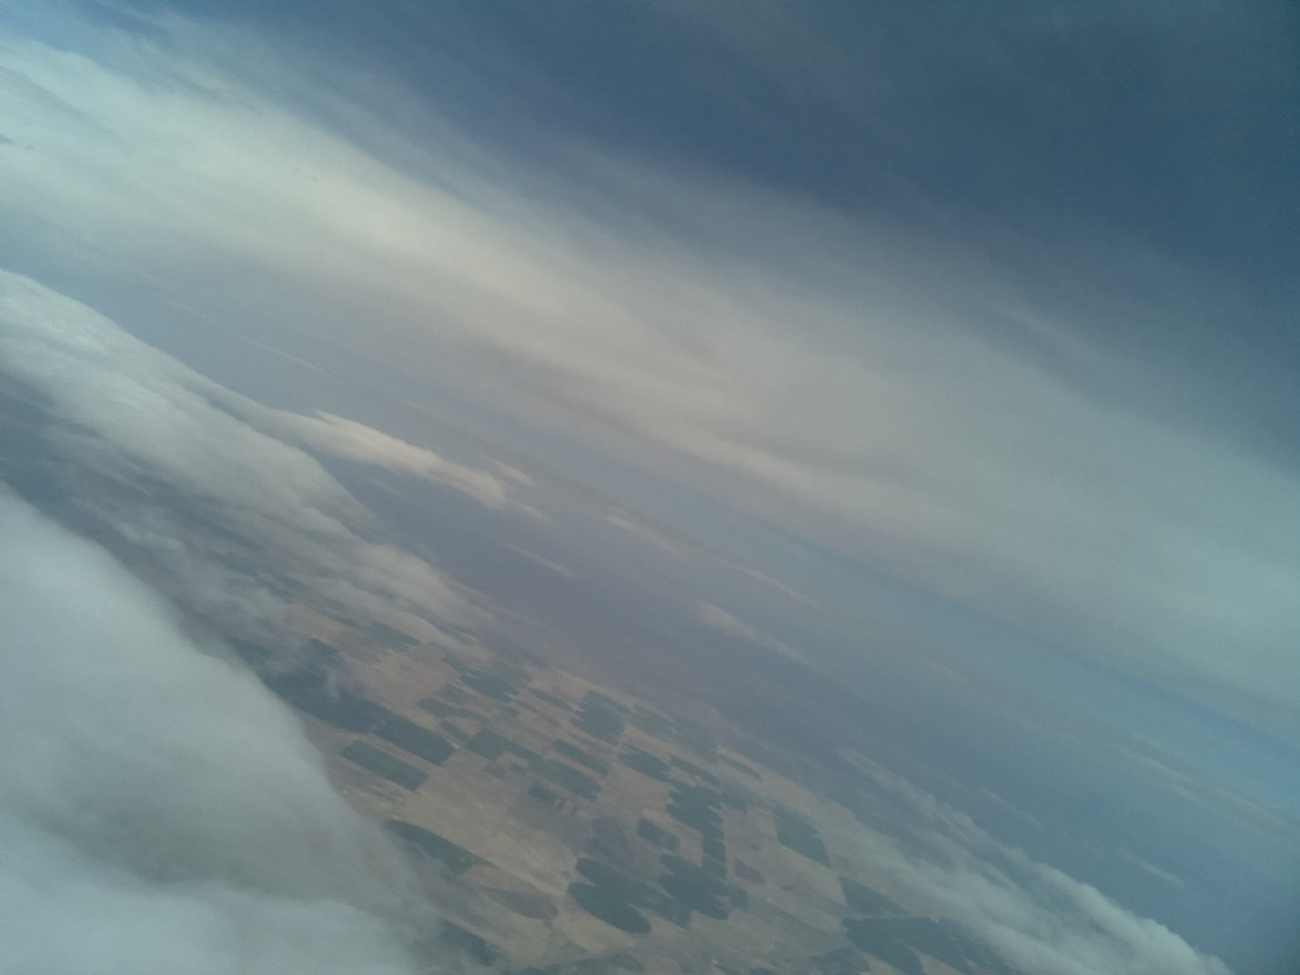

(Near 65,000 ft)

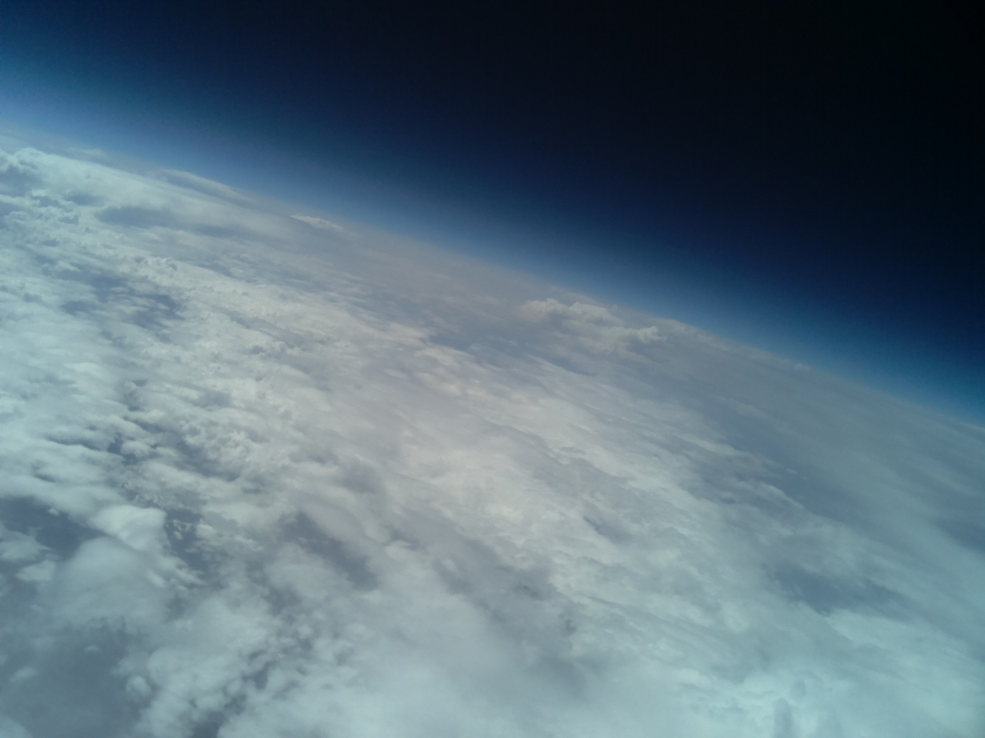

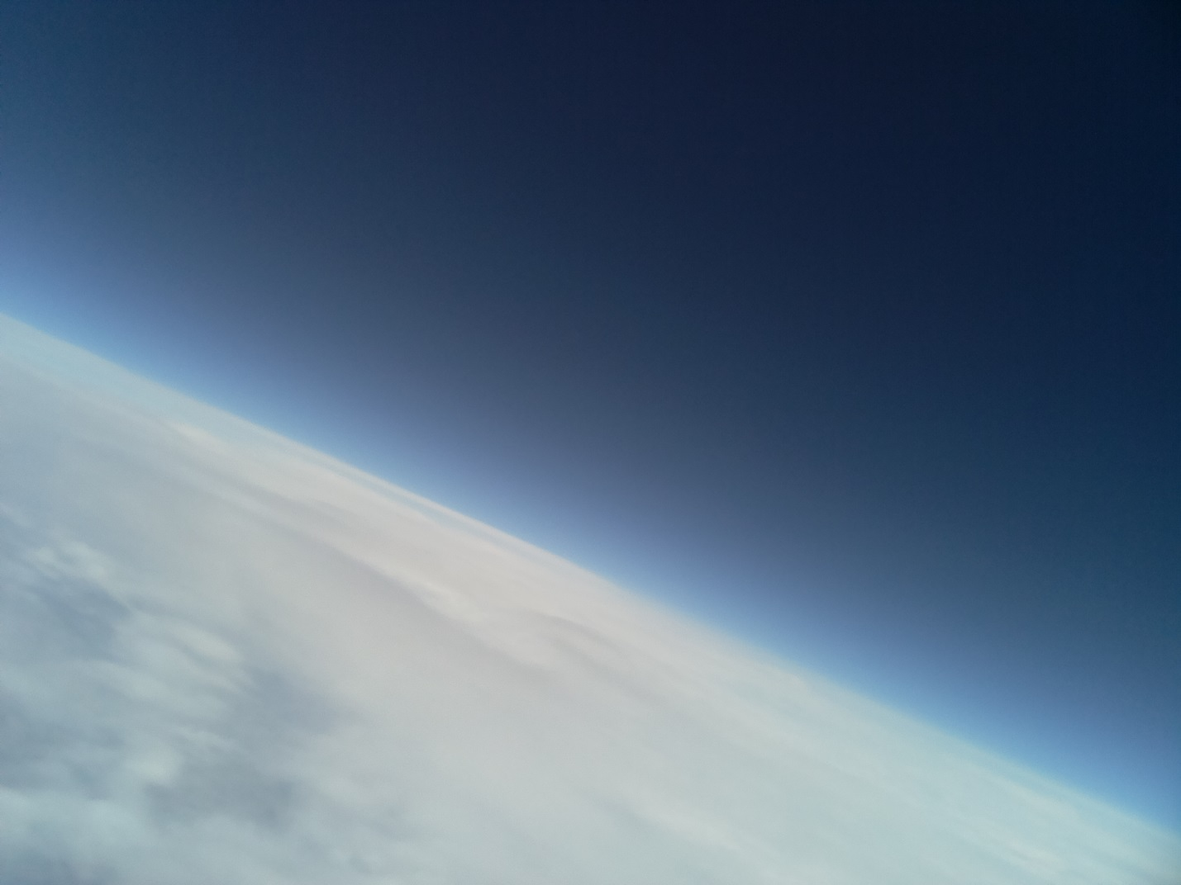

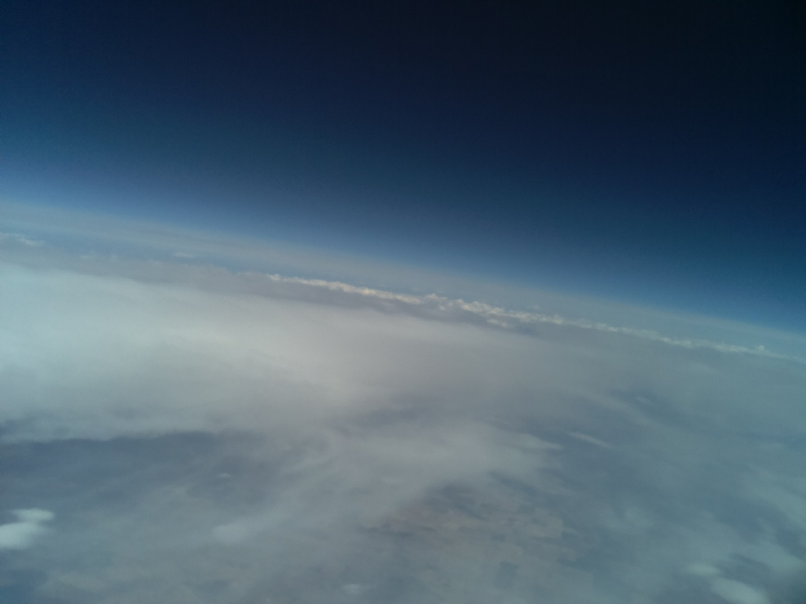

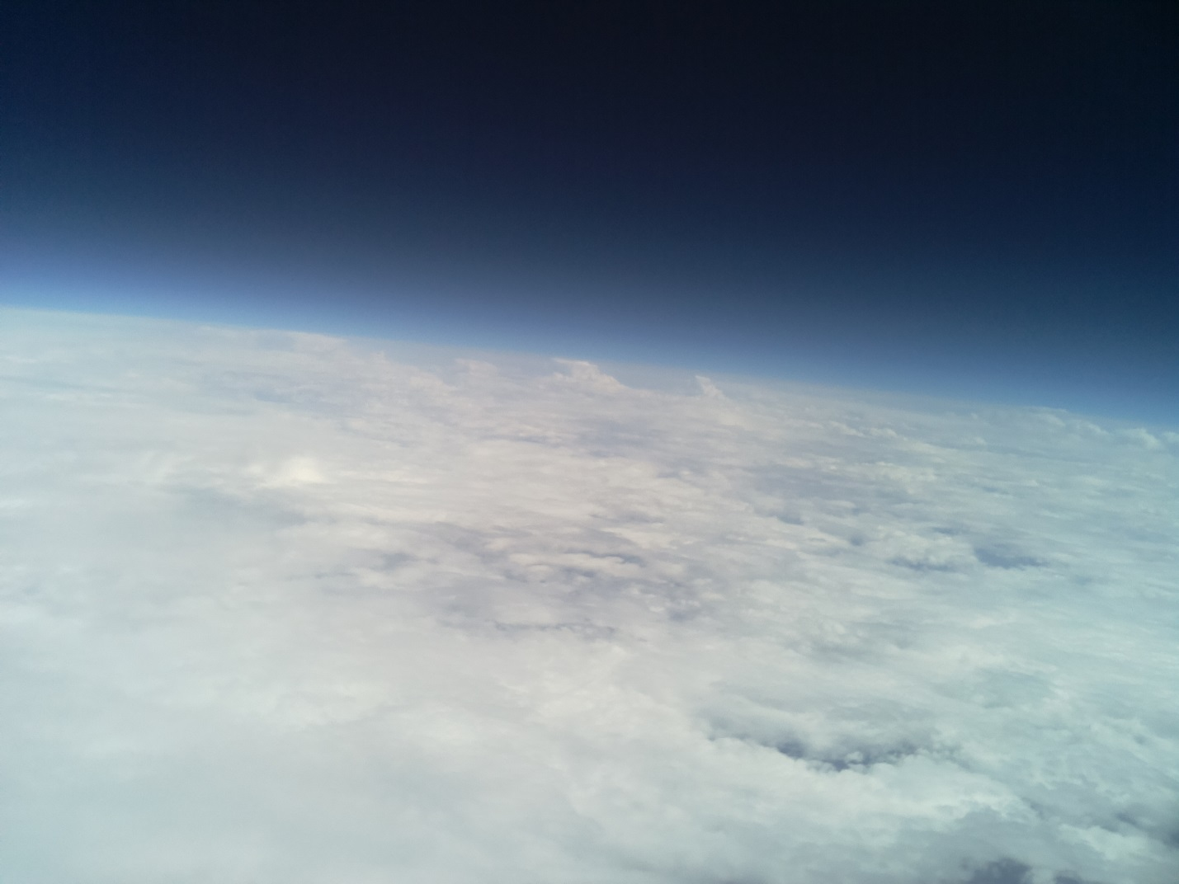

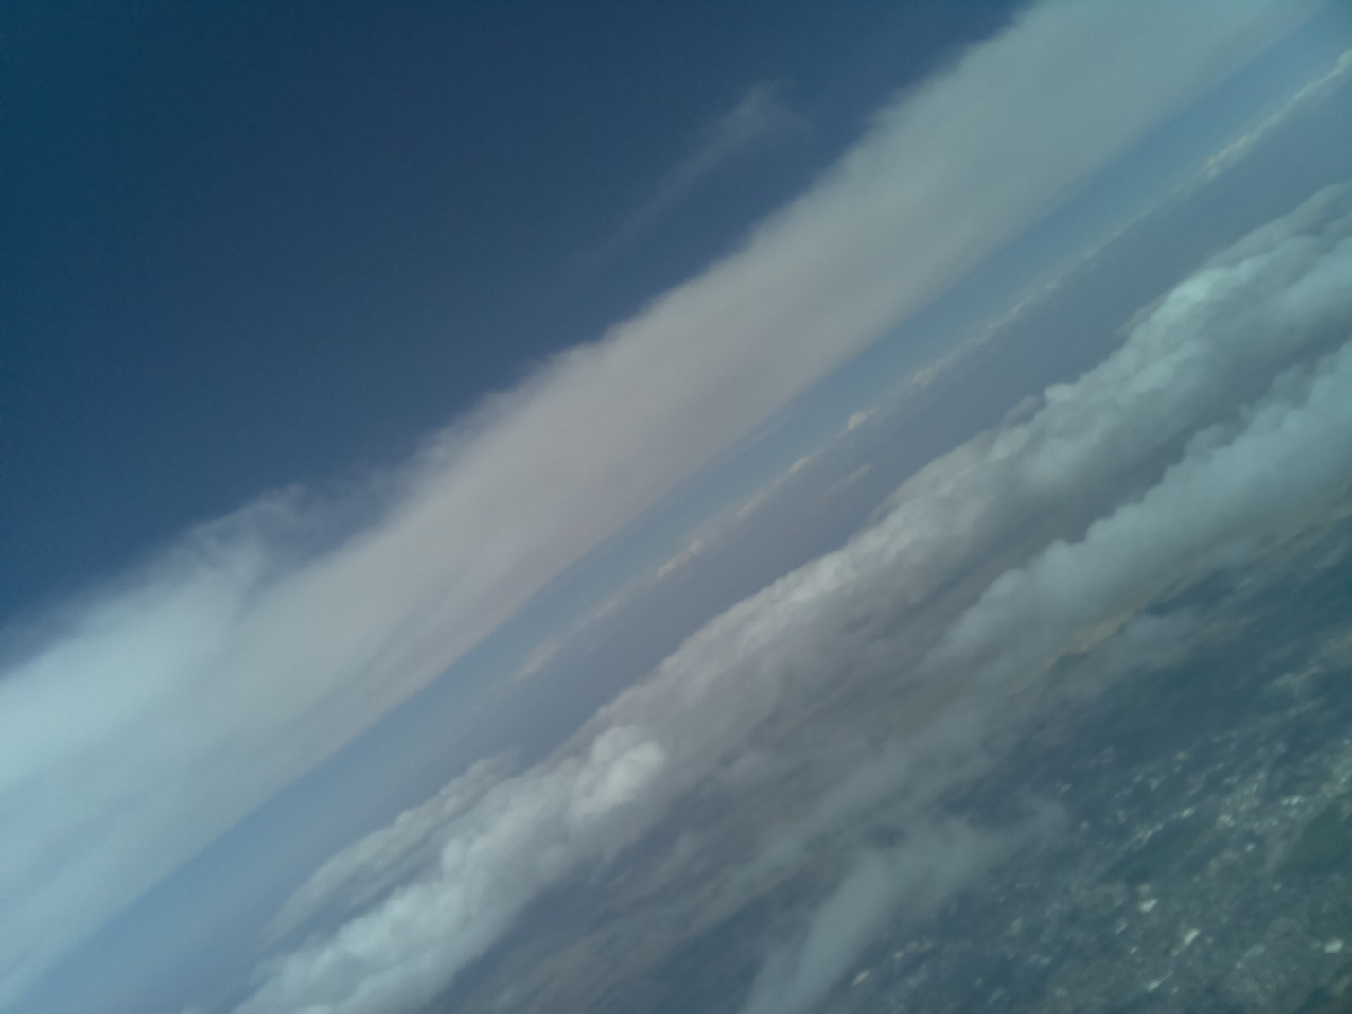

(W/ adjustments, downward facing camera)

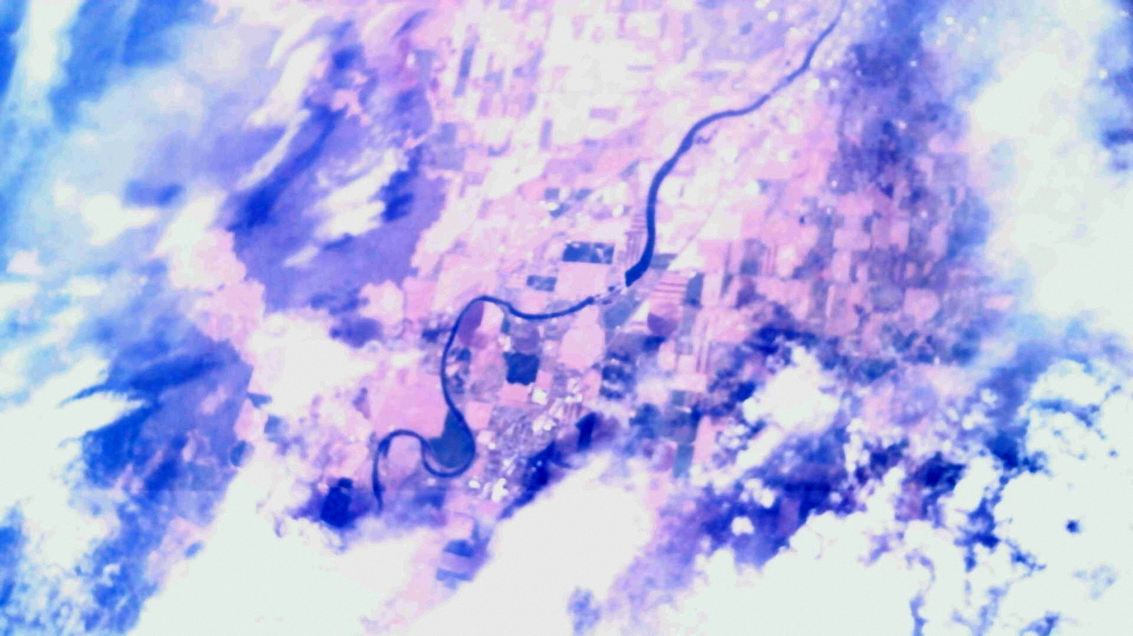

Landing

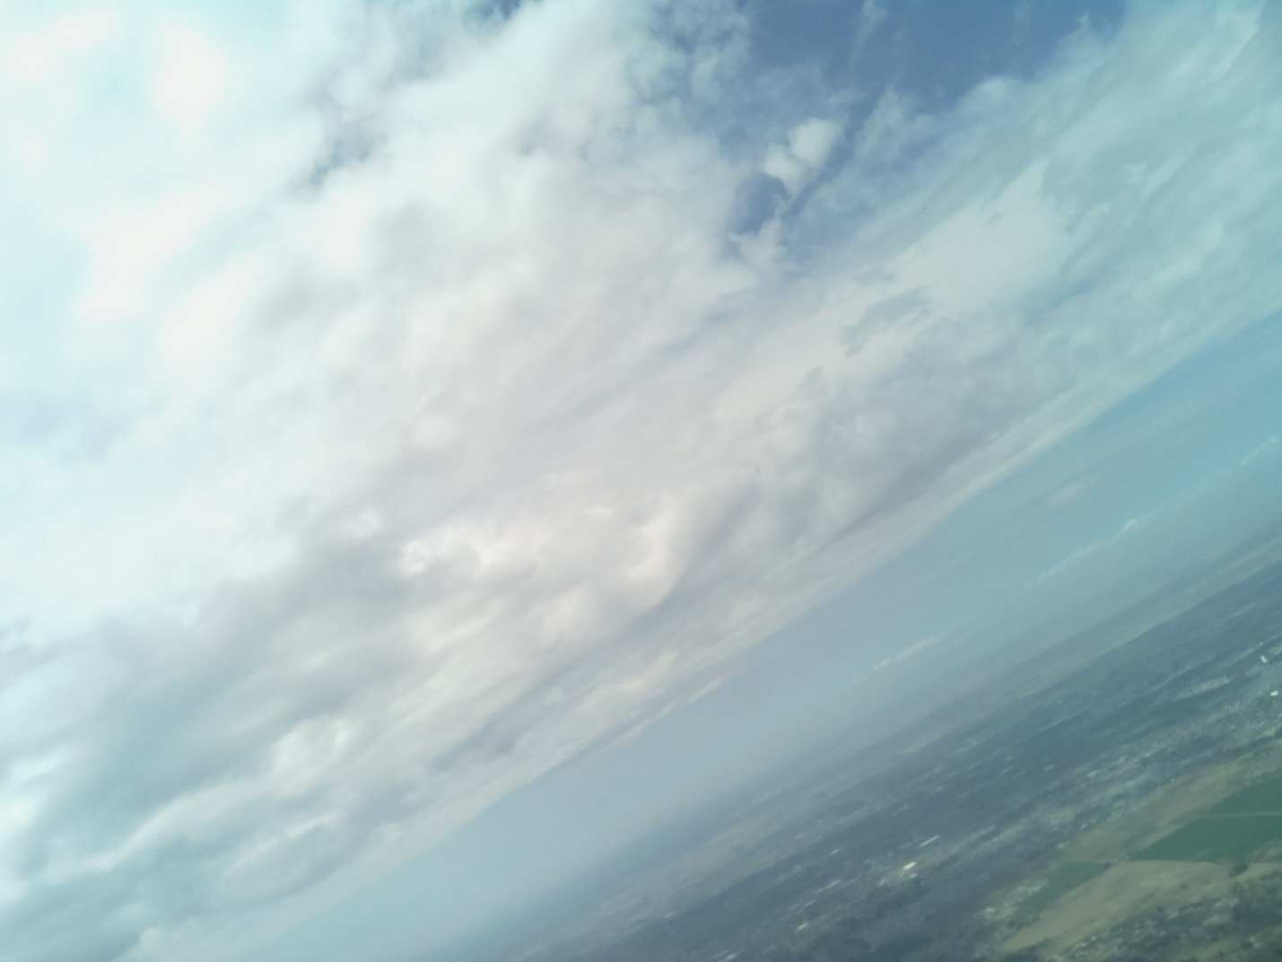

Landing

(East of Idaho Falls, on foot hills, Bonneville County Idaho)

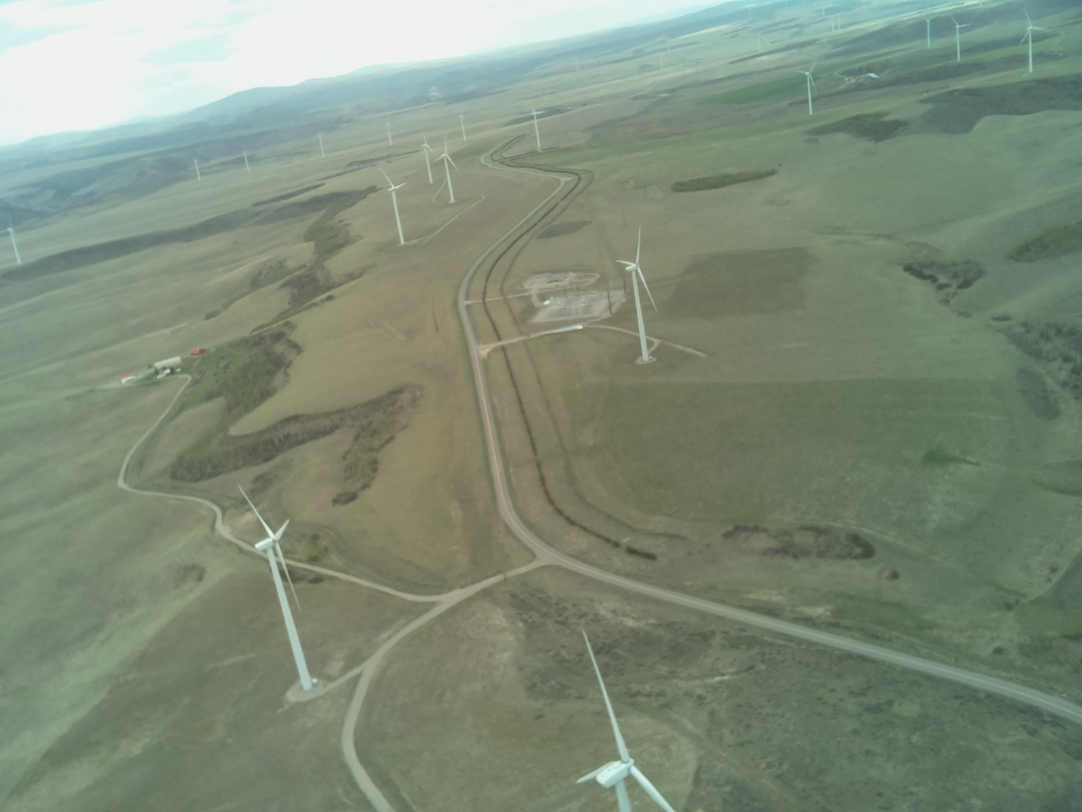

Landed

(Odds of landing in a tree?)

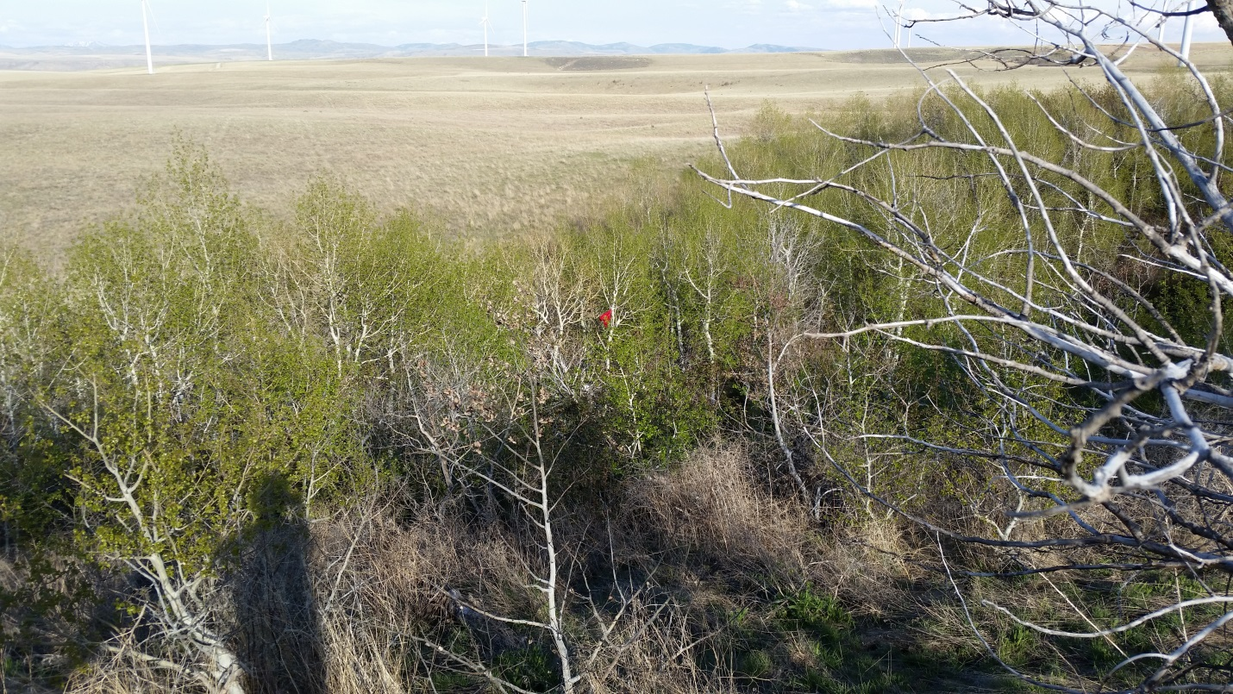

Recovery (apx 5600ft)

